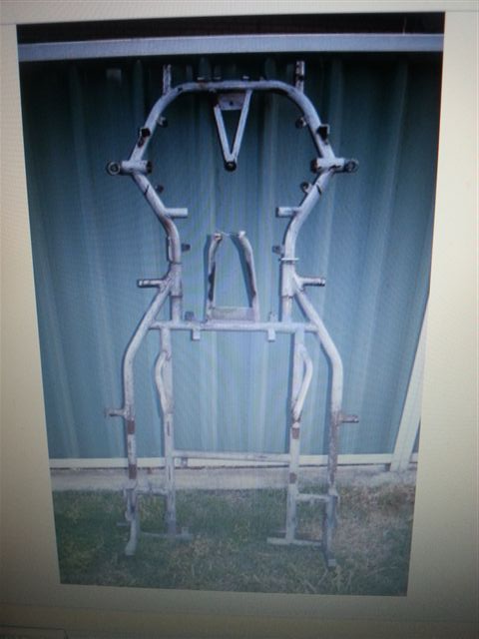
IT ALL STARTED WITH A $50 FRAME
PURCHASE FROM EBAY
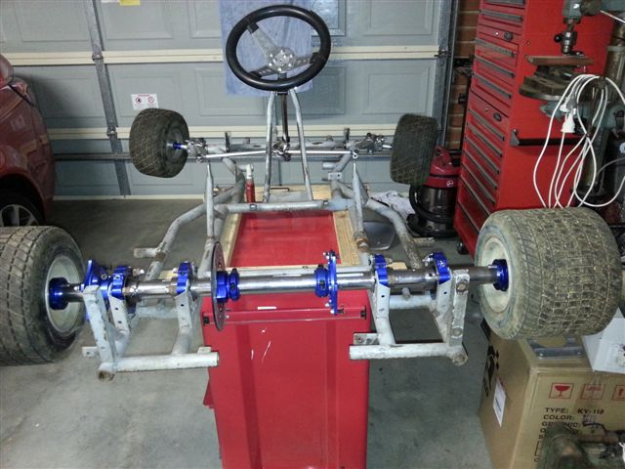
NEXT, MOCK UP STARTED WITH MAINLY CUT PRICE RACING PARTS

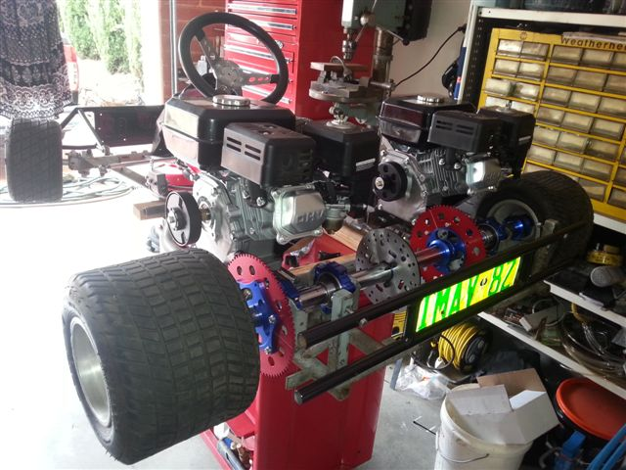
PAGE 1
MOCK UP COMPLETE.
TIME TO DISMANTLE FOR THE FINAL TIME AND SEND FRAME TO SAND BLASTERS AND THEN FOR POWDER COATING TO PAINT FRONT AND REAR NUDGE BARS.

