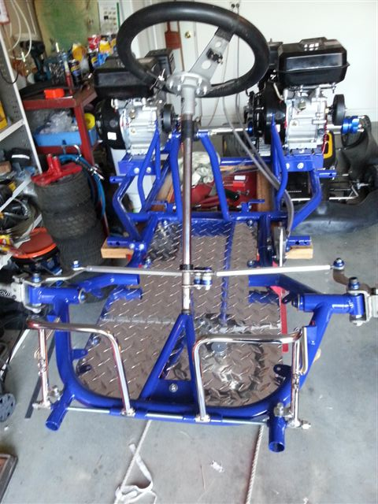
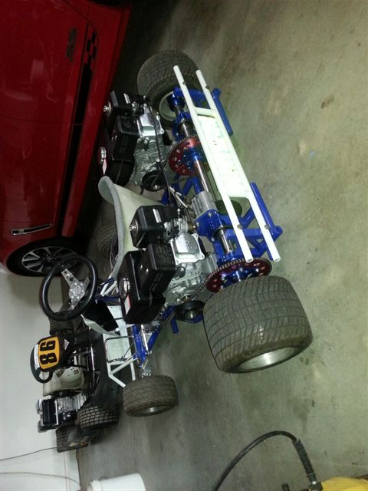
FINALLY, BACK FROM POWDERCOATING, NOW TO START ASSEMBLY FOR THE FINAL TIME
FINALLY FINISHED, TIME FOR FUN...
2 X HONDA CLONE MOTORS, GOVENORS REMOVED.
CPR SPINDLES,AXLE KIT, BEARINGSM ACCELERATOR CABLES, STEERING LINKAGES AND SHAFT, SEAT, RACE BRAKES, CHAINS CLUTCHES AND SPROCKETS.
FRONT SPROCKET 12T
REAR SPROCKET 73T
FRONT RIMS 5”
REAR RIMS 6”



